Dear _(amazing boss)_,
I’d like to kindly ask for your approval to attend SmashingConf 2020 (www.smashingconf.com/sf-2020) that will be taking place in San Francisco on April 21–22, 2019. There are many conferences out there, but I’ve picked this one because I feel that the insights and learnings presented and discussed there are exactly what our team needs in our company to get more efficient, stay ahead of competition and avoid unnecessary costs.

Unlike big-scale conferences which often have subpar sessions and a lot of time is lost moving from one huge hall to another, Smashing Conference is quite small (400 people), and hence very focused and well-curated. They’ve been known for a strong commitment to very practical sessions and hands-on workshops. In fact, I like that they have live interactive sessions where experts actually show how they work, build, refactor, debug, sketch and redesign — live on stage.

As they say, the entire conference is built on top of “real-life examples, case studies and practical techniques applicable to your work right away”. So I would see how other companies work, design, build and what mistakes they’d done in the past, and what we can learn from it.

Advantages for our company

The learnings from two conference days will help our company to:

- Design better processes to design, build, debug and deploy faster,
- Improve performance and responsiveness of our web properties,
- Increase web security and reduce our surface area for attacks,
- Improve accessibility and flexibility of our front-end architecture,
- Set up a proper strategy for maintainable design systems, so we don’t have to reinvent the wheel all the time.
My personal advantages
I sincerely appreciate the opportunities to grow as a professional in our company, and I’m very excited about this conference because:
- There’s an impressive line-up of experts who are working with technologies, tools and methodologies we use daily,
- Hands-on workshops with experts give me an opportunity to learn new practices and techniques and improve my skills right away,
- The friendly, intimate spirit of the conference make it easy to interact with speakers and ask questions,
- As the conference attracts seasoned designers and developers, I’m excited to learn from 400 professionals and discover their experiences and best practices from their projects,
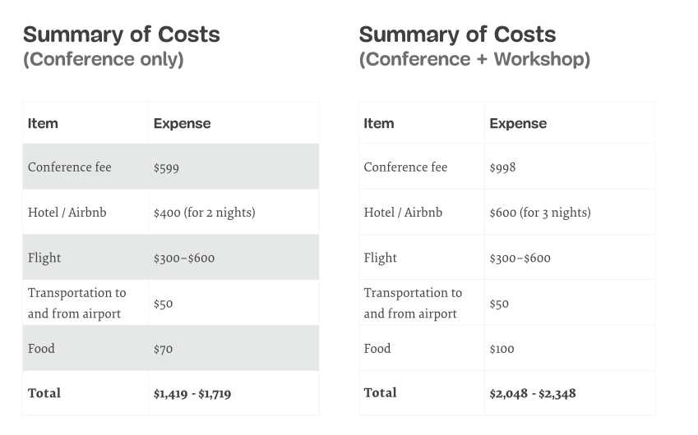
- Because front-end is changing rapidly, I feel it’s important to learn what’s possible these days, and where the front-end/UX are heading these days.

On a personal note, I’ve been following Smashing for years now. Smashing Magazine, by the same folks who run the conference, has been around for more than 12 years, and it’s been my trusted source for cutting-edge design and development practices that helped me grow as a professional in the industry. I feel confident that I’ll bring back a ton of useful notes and takeaways for the team, and I’m looking forward to improving our efficiency and reducing unnecessary costs. The conference also provides slides and videos of presentations that we could use internally as well.

I’d kindly appreciate you considering my letter, and I hope you have a moment to take a look at the website — www.smashingconf.com/sf-2020 — and the overview of topics covered there. I couldn’t be more excited to attend this one, and I’m quite certain that it’s a good investment in training for our entire company.

Thank you for your time.

— Yours truly __EMPLOYEE’S NAME__,
an employee, passionate about learning new skills.

